# Fitness First Gym

**Team Leader:** Mohsin Ali

1. Muhamamd affan katiya - 1290618
2. Mohsin Ali - 1286696
3. Muhammad Shayan - 1303870

# Purpose

A gym application, often referred to as a fitness or workout app, serves various purposes and provides a range of functionalities to help individuals achieve their fitness and health goals. The primary purposes of a gym application include:

1. **Workout Planning:** Gym apps offer users the ability to plan and schedule their workouts. They provide a library of exercises and pre-designed workout routines tailored to different fitness levels and goals, such as weight loss, muscle building, or cardiovascular fitness.
2. **Tracking Progress:** Users can track their fitness progress over time. This includes recording workouts, measuring body measurements, and tracking weight and body composition changes. Progress tracking helps users stay motivated and see the results of their efforts.
3. **Nutrition and Diet:** Many gym apps offer features for tracking nutrition and calorie intake. Users can log their meals, calculate their daily calorie needs, and set nutritional goals. Some apps even provide meal plans and recipes.
4. **Goal Setting:** Users can set fitness goals, whether it's running a certain distance, lifting a specific weight, or achieving a target body fat percentage. The app helps users create achievable milestones and tracks their progress towards these goals.
5. **Guided Workouts:** Some gym apps offer guided workout videos and audio instructions, making it easier for users to perform exercises with proper form and technique.
6. **Social and Community Interaction:** Many gym apps have social features that allow users to connect with friends, share their achievements, and participate in challenges or competitions. This social aspect can enhance motivation and accountability.

# Requirements

## *Introduction : –*

“Fitness First GYM” is a leading GYM in town. With increasing number of members and new registrations happening, it has become difficult for owners to maintain records manually. They are looking for better Online Website to improve the system of record keeping and facilitate its members with membership details.

***Proposed Solution :*** –

“Fitness First GYM” is looking for software designed to make it easy to maintain detailed records of members and their memberships, book classes and trainers, process and track sales, and communicate en mass with the right members at the right time.

Designed to fit clubs of all sizes, this gym software should be feature-packed. With a full booking system, point of sale, website integration, billing integration, online booking for clients.

This software will help to run the GYM more efficiently.

# System Modules:

**Guest Users**

* Guest user can view the website and check out the information about GYM.
* Guest users can also inquiry through contact us page.
* General information about trainers and equipment’s should be mentioned.

**Register Users**

* Users can visit the website and apply for GYM packages.
* Registration: One time Registration is required to apply for any GYM package.
* Login: After registration, the user can log in and apply for the GYM package.
* Booking History: In this section, users can see booked packages and payment details also.
* Profile: In this Section, User can update their profile.
* Change Password: In this section, user can change their own password.

**Admin**

Admin is the super user of the website who can manage everything on the website. Admin can log in through the login page

* Dashboard: In this section, Admin can see the overview of bookings, listed packages, categories, and package types.
* Categories: In this section, the admin can add, and delete the categories.
* Package-Type: In this section, the admin can add, or delete the package type.
* Packages: In this section, admin can add, and edit packages;
* Bookings: In this section, the admin checks the new booking and partial/ full payment bookings. Here admin can also update the payment details against particular booking.
* Report: In this section, Admin can generate the between dates report for booking and registered users.
* Admin can also update his profile, change the password and recover the password

# Use case diagram

Clas

# Class Diagram



# Acitivity diagram

# 

## Application Arctechture



# Data flow Diagram

## Level 1



## Level 2



## Level 3

# Guest User

## Home

Here guest user can see packages, trainers and also he can contact to admin. He can register his self and can login.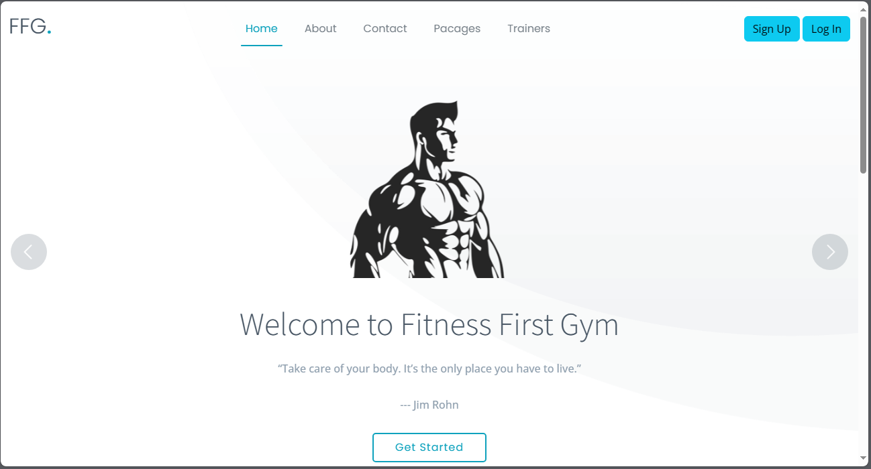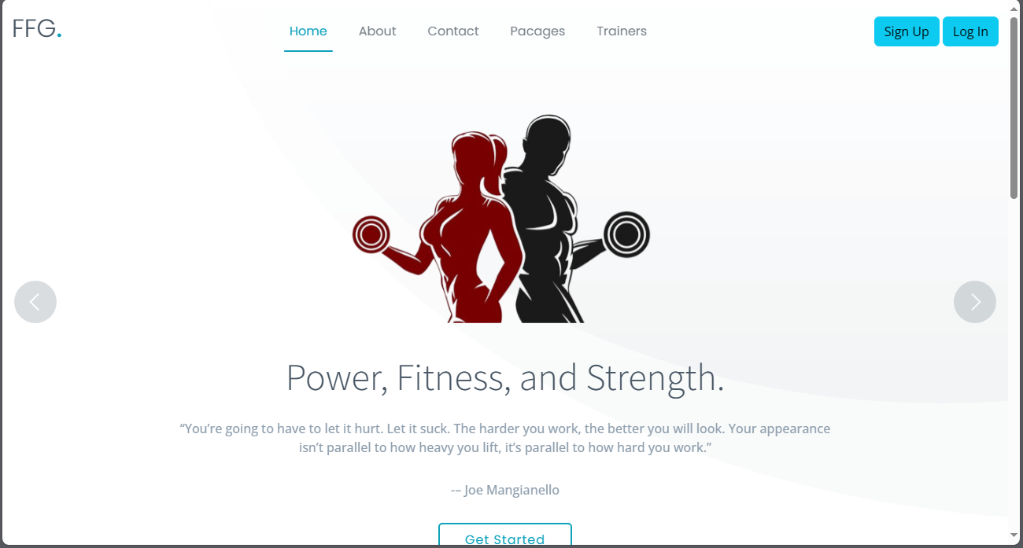

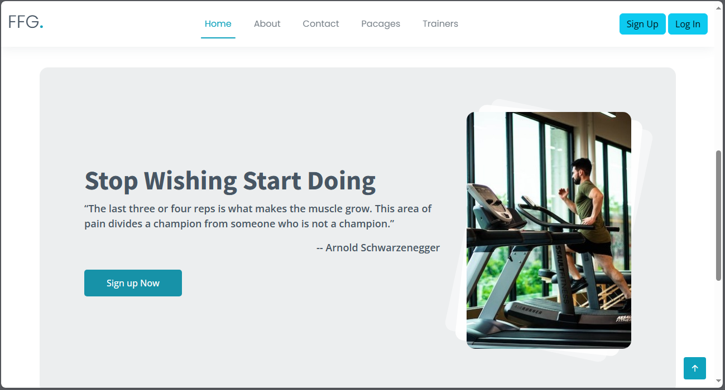

## Packages

Here guest user can see categories and package types and packages.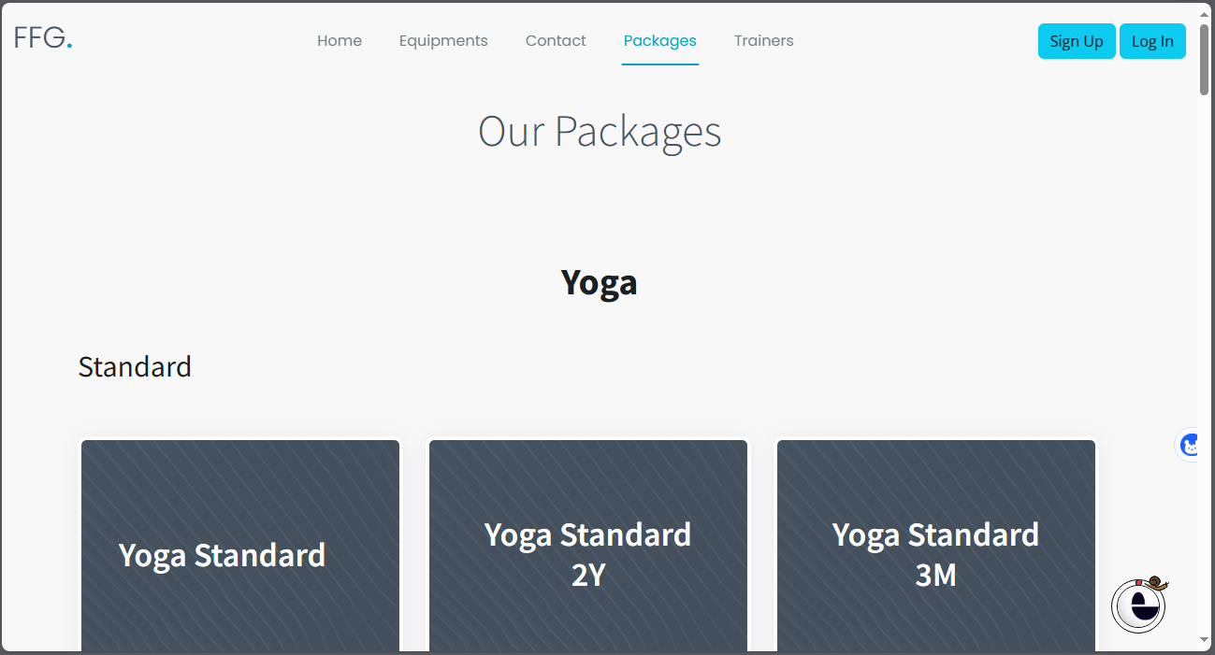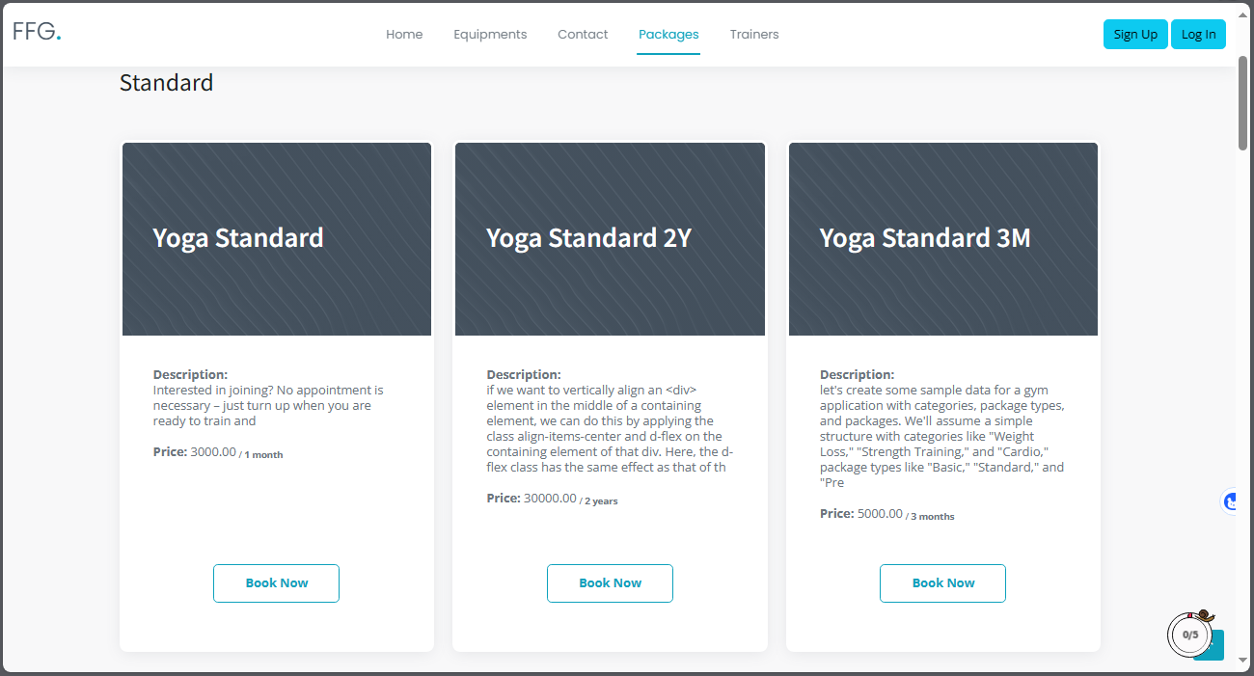

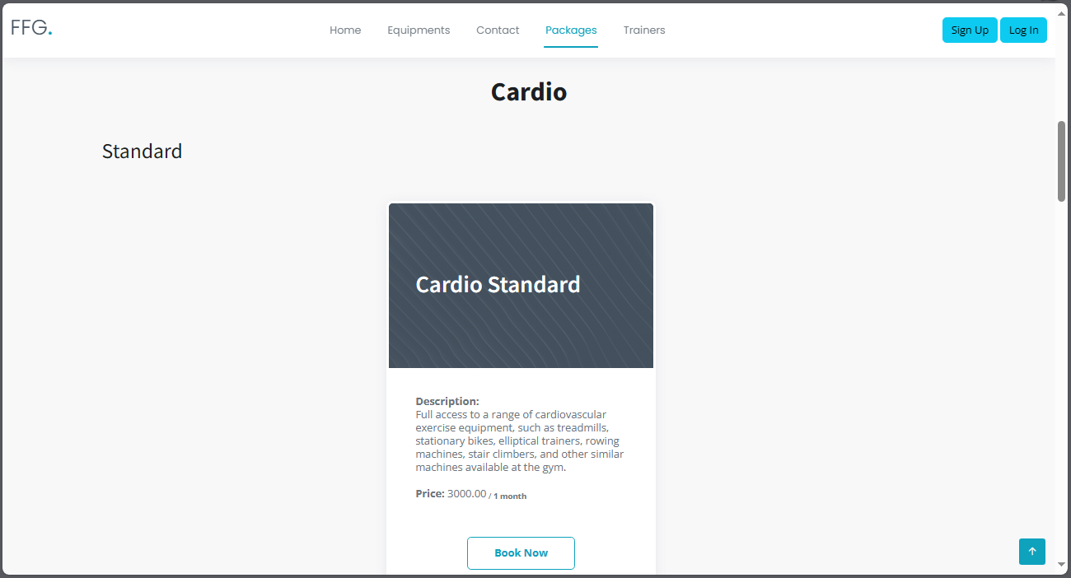

# Contact Us

Here user can contact the admin and see the location of the gym and also get the phone number.

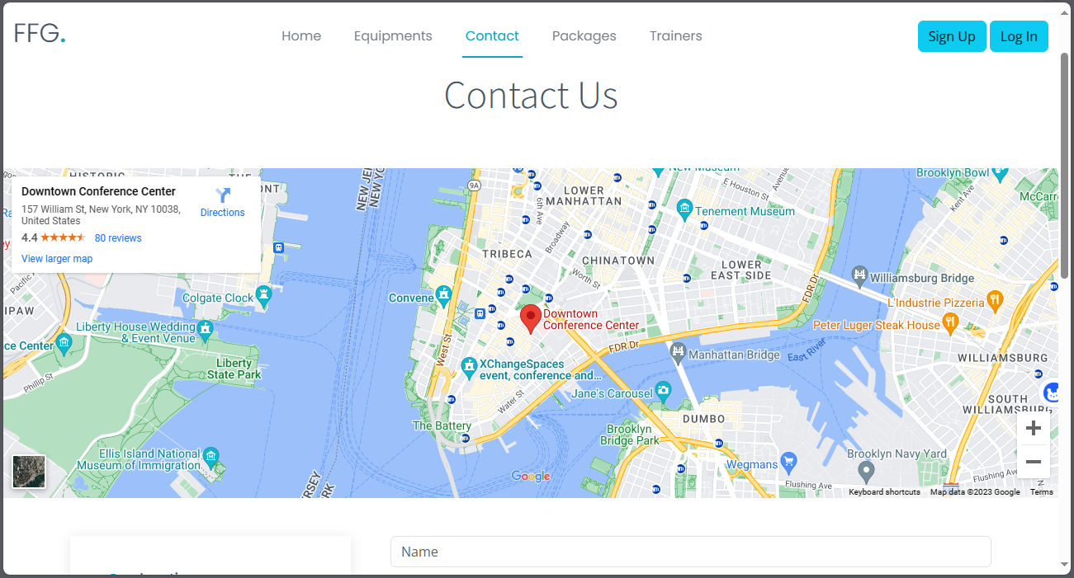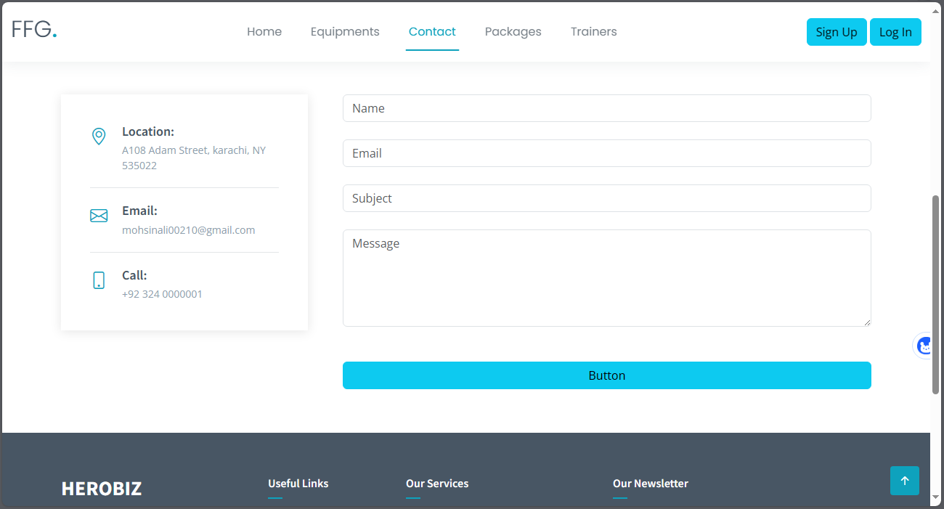

# Trainers

Here user can see the info formation about trainers. Like trainer’s experience and sc

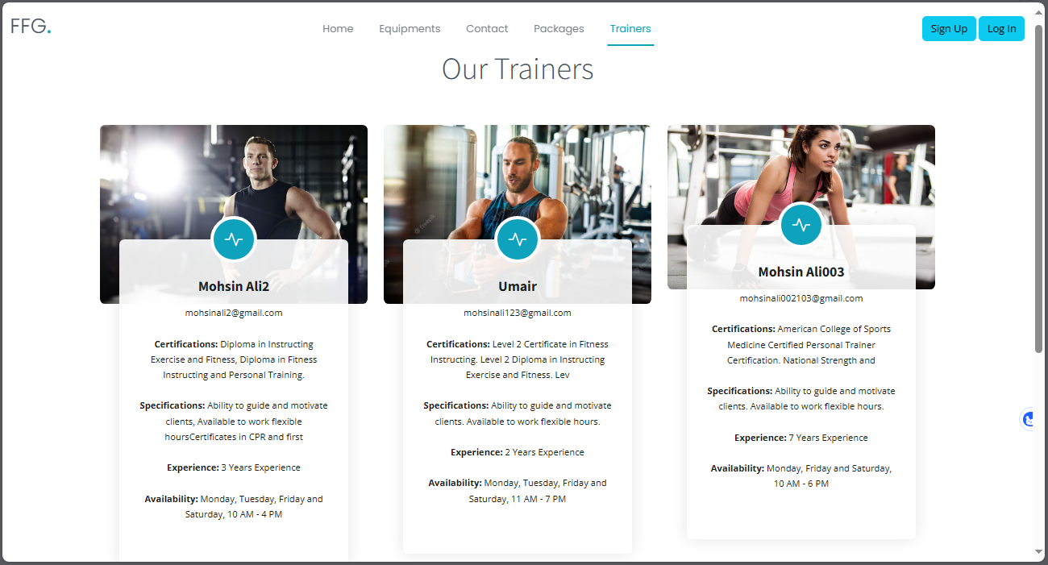

# Sign up

Here guest user can register him self.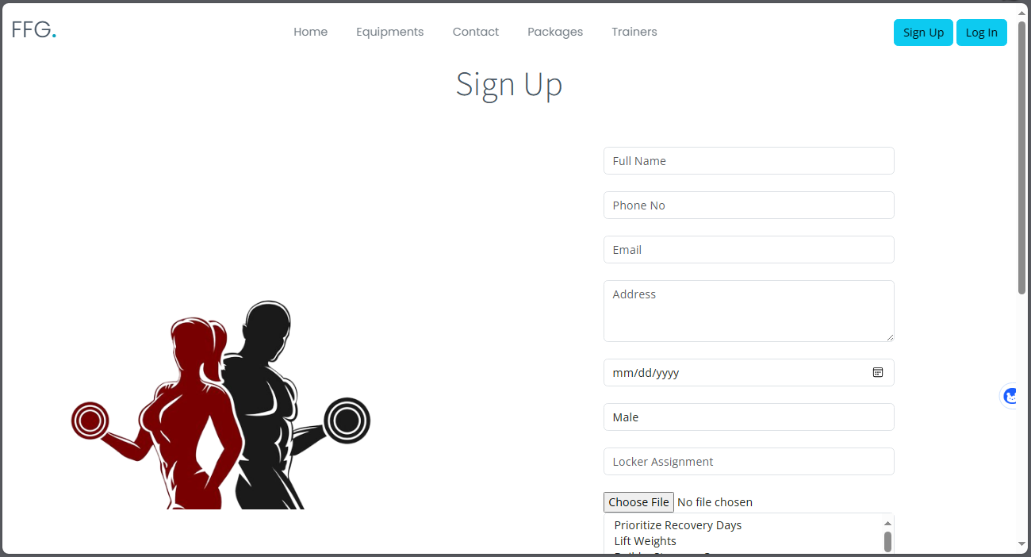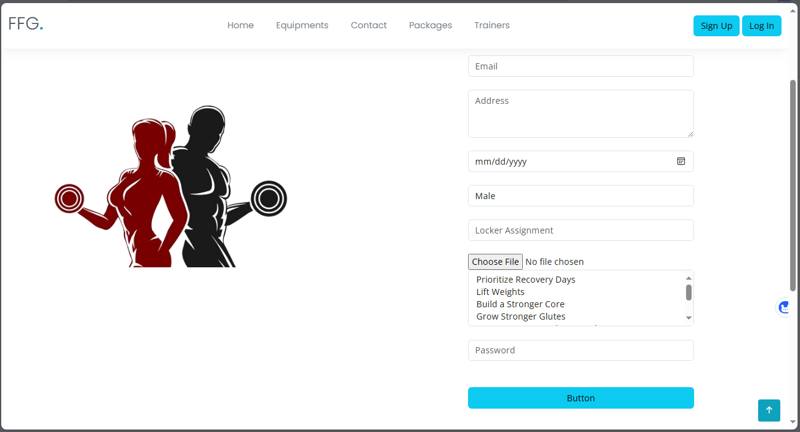

# Sign In

Here user can login there account.

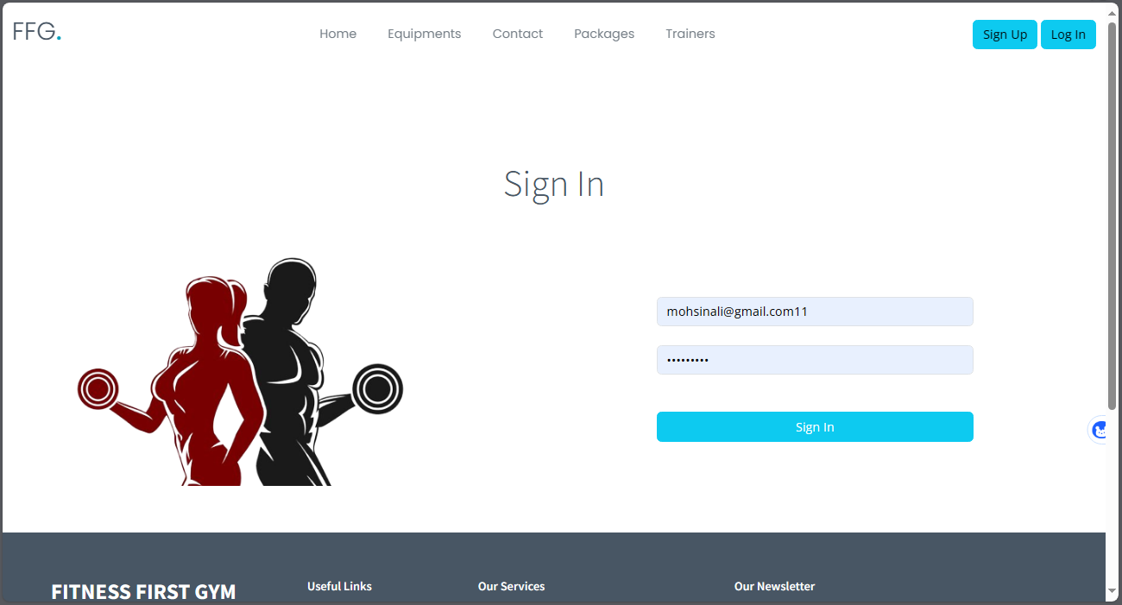

After loging in user will see the message of successfully login.

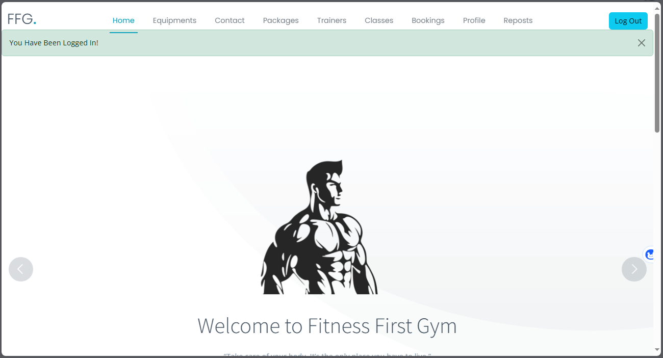

# Registered User

## Packages

Here registered user can apply for package by clicking on buy no button

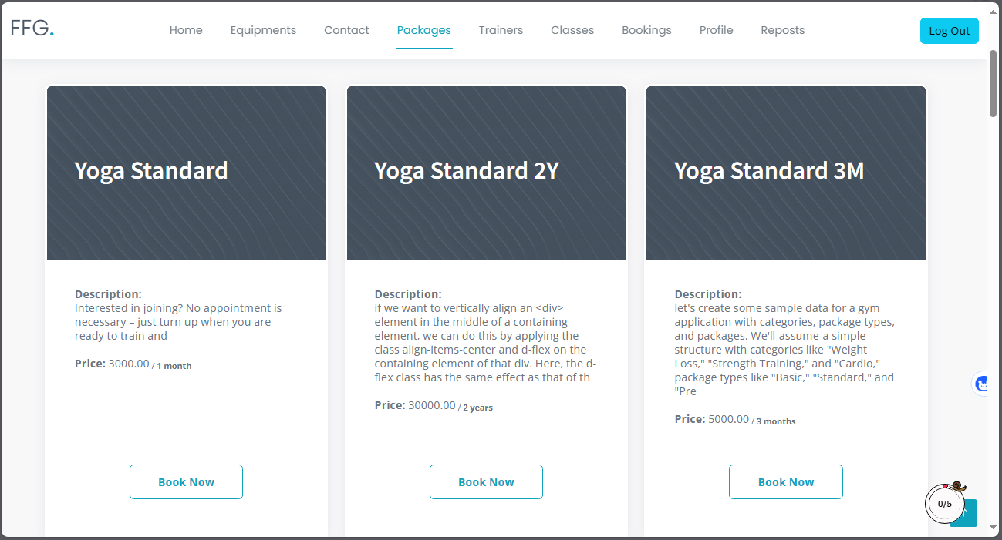

User will see this form after clicking on buy now button

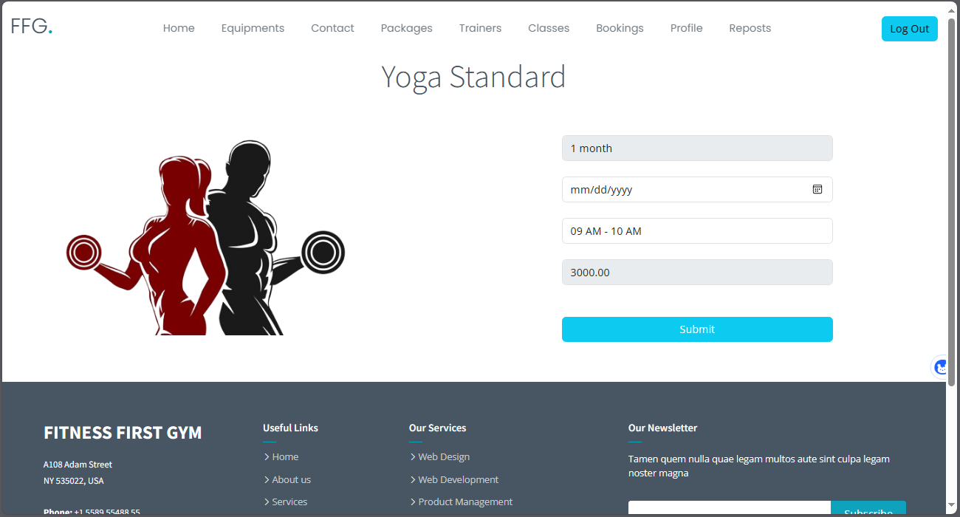

# Booking

Here user can see their booking history. And also see their payment status and amount paid.

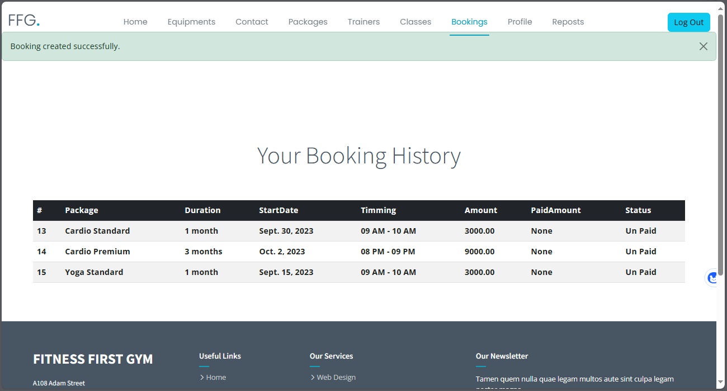

# Reports

Here user can see reports and their types.

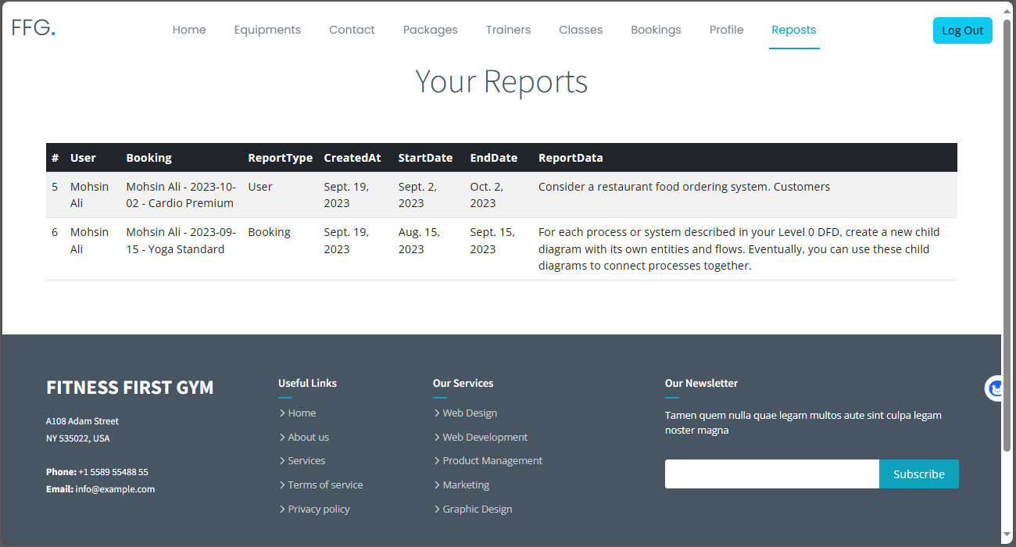

# Sign out

Registered user can sign out by clicking on sign out button.

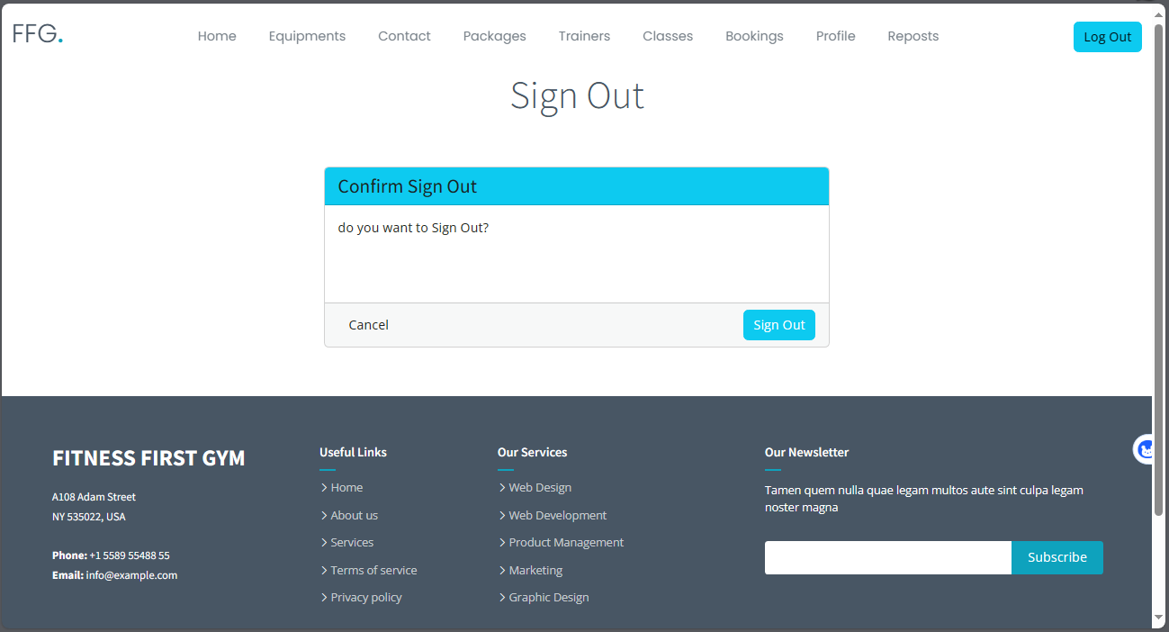

After confirming the logout.

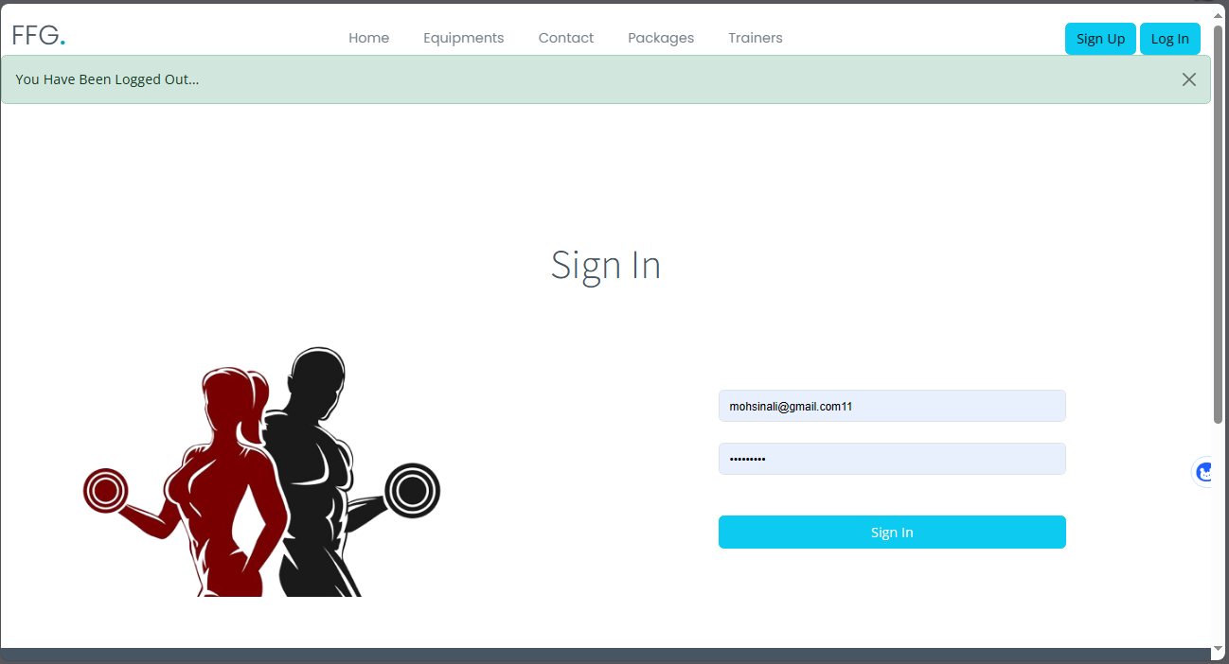

# Admin

# Log In

Admin can log in to the dashboard.

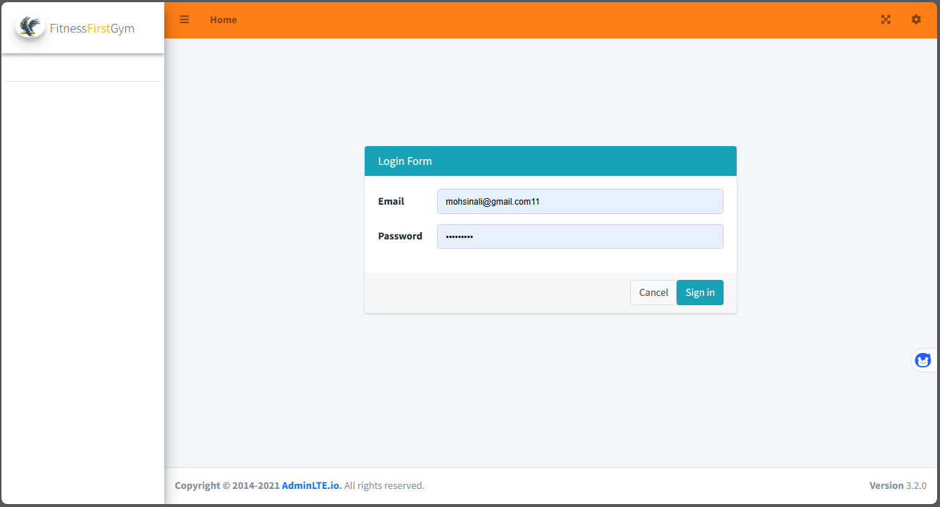

# Home

Alter successfully loging in user will be redirect to

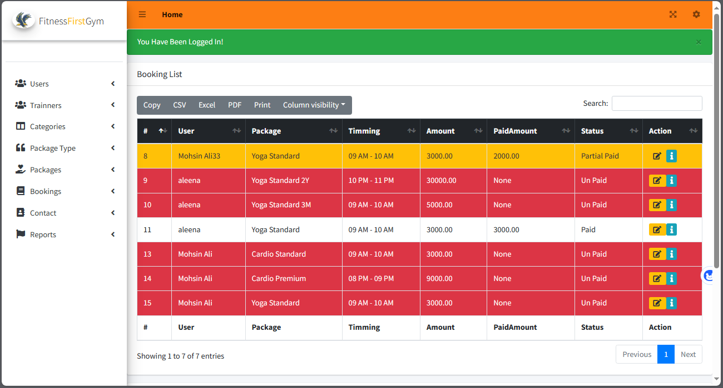

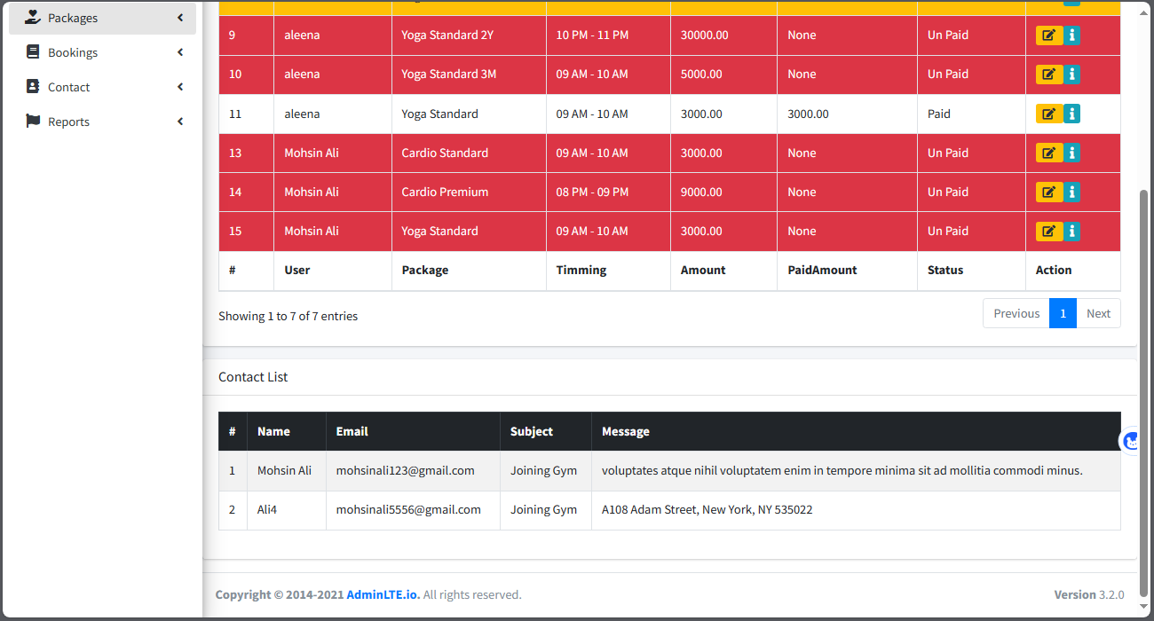

# User List

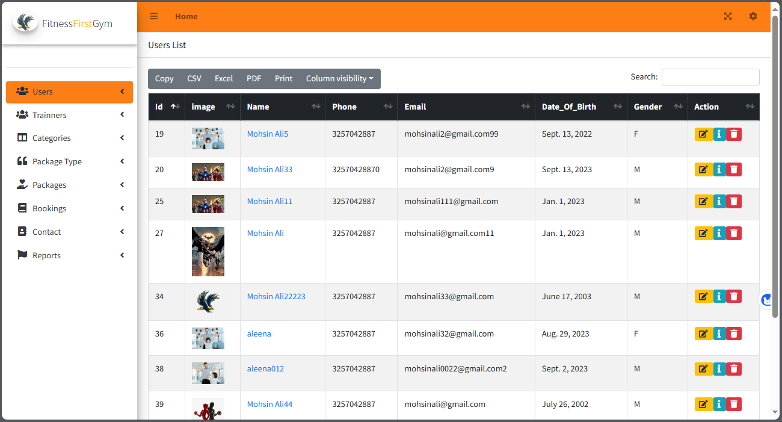

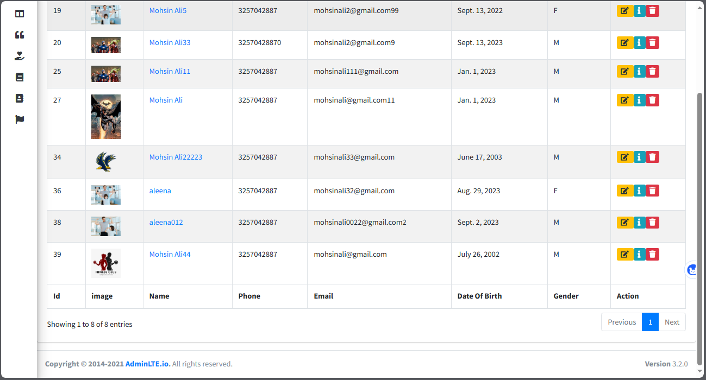

# User Edit

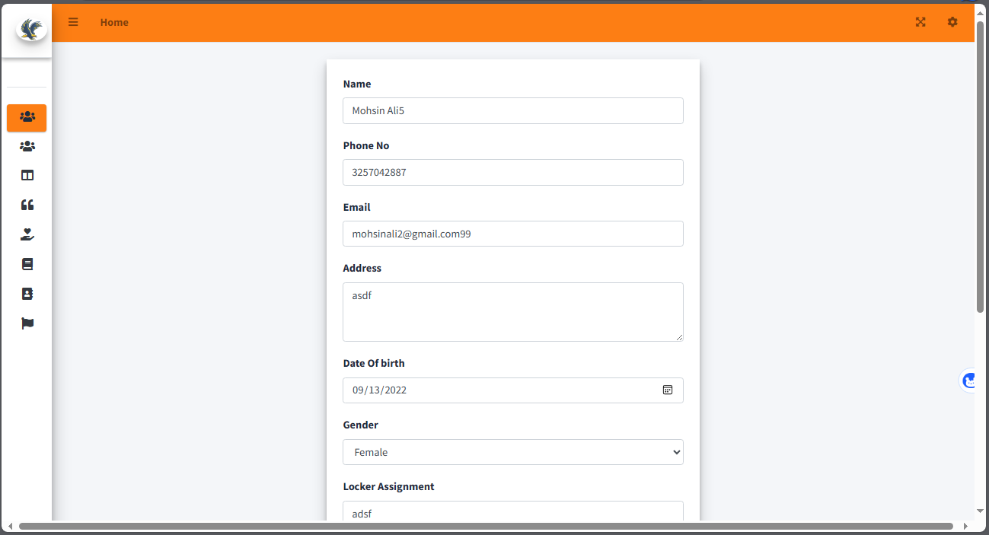

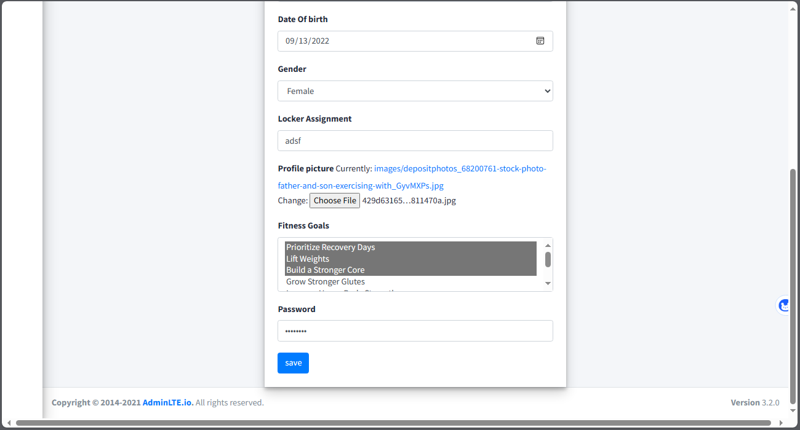

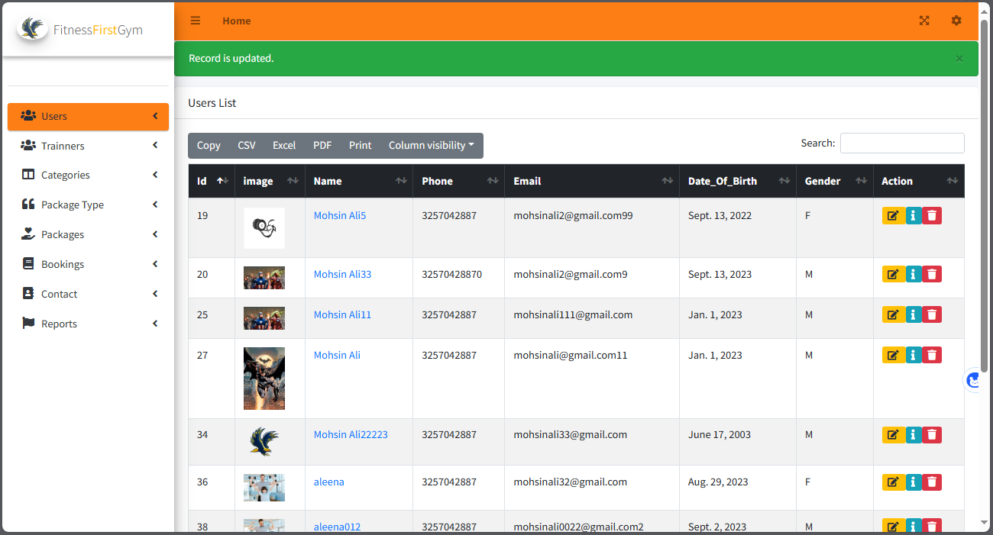

# User details

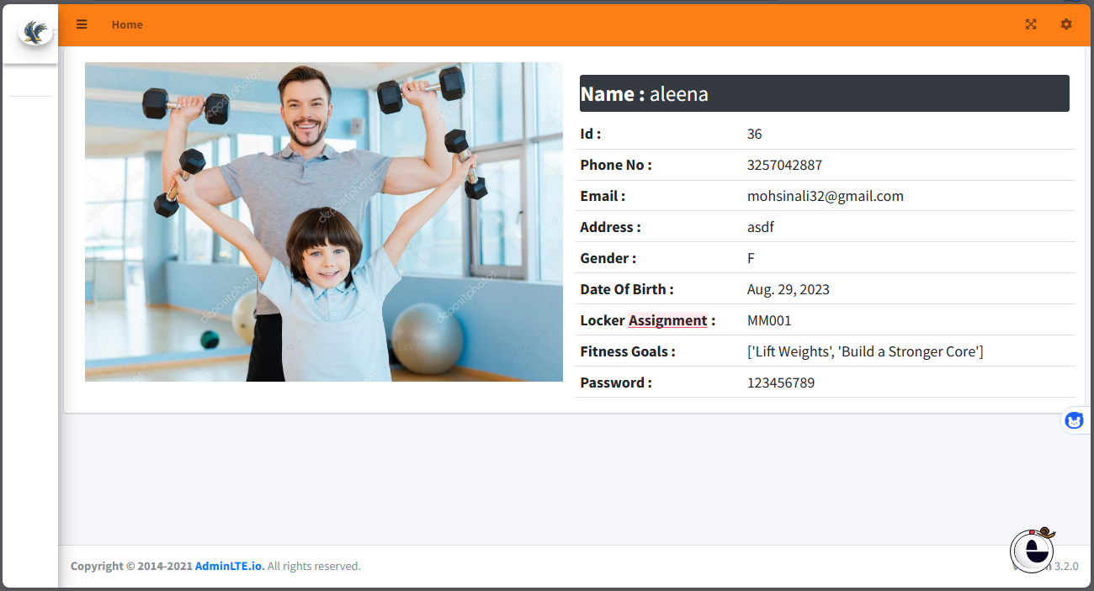

# User create

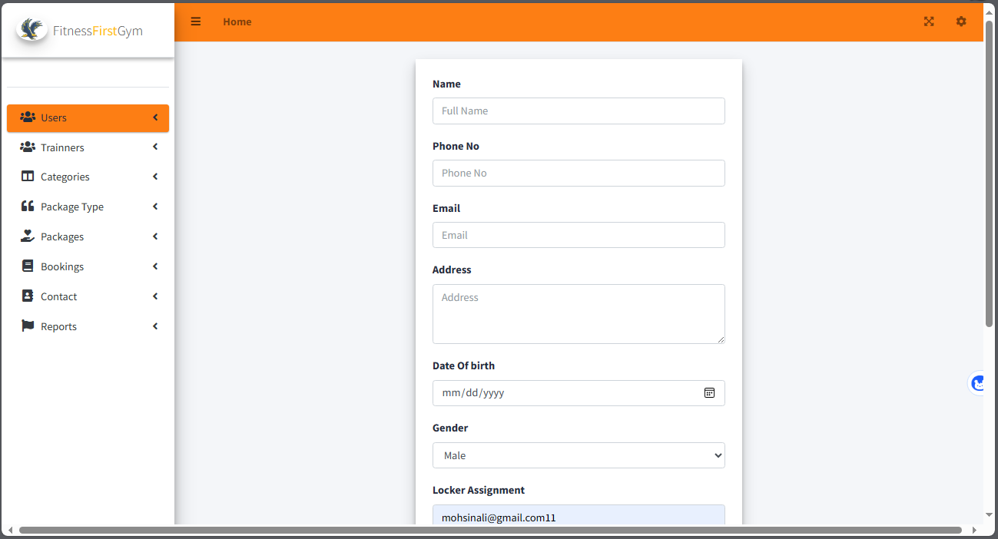

# Trainer List

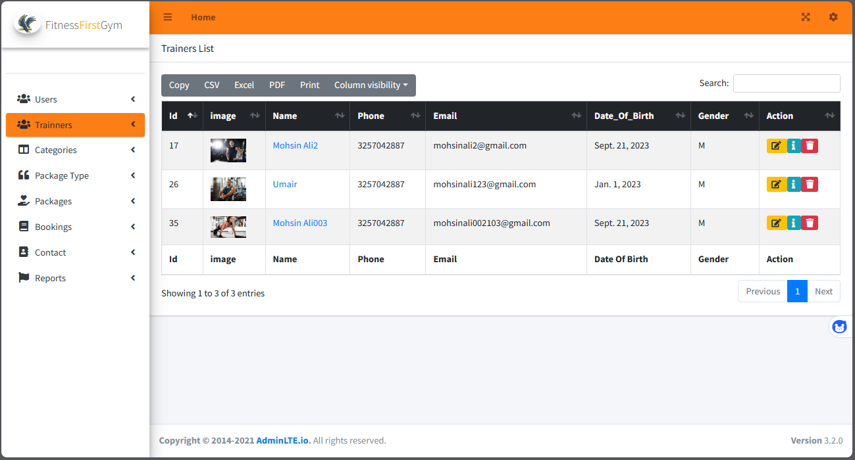

# Trainer create

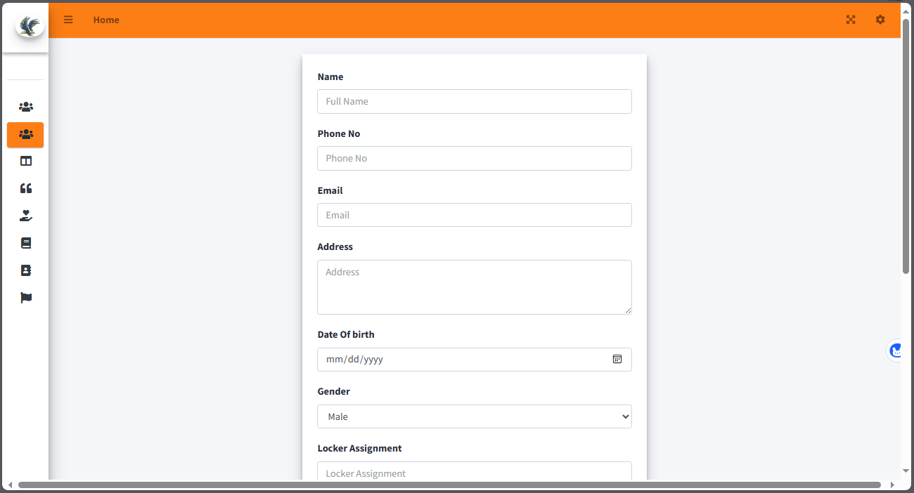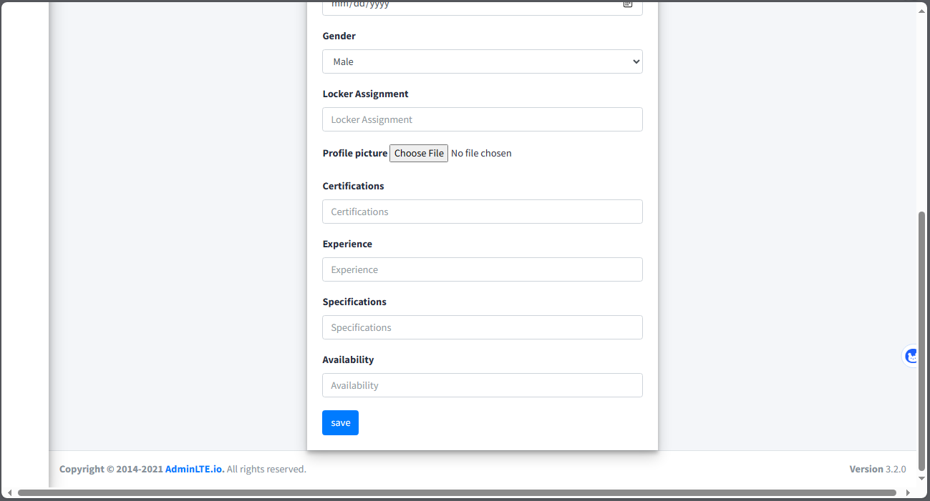

# Category List

# Category edit

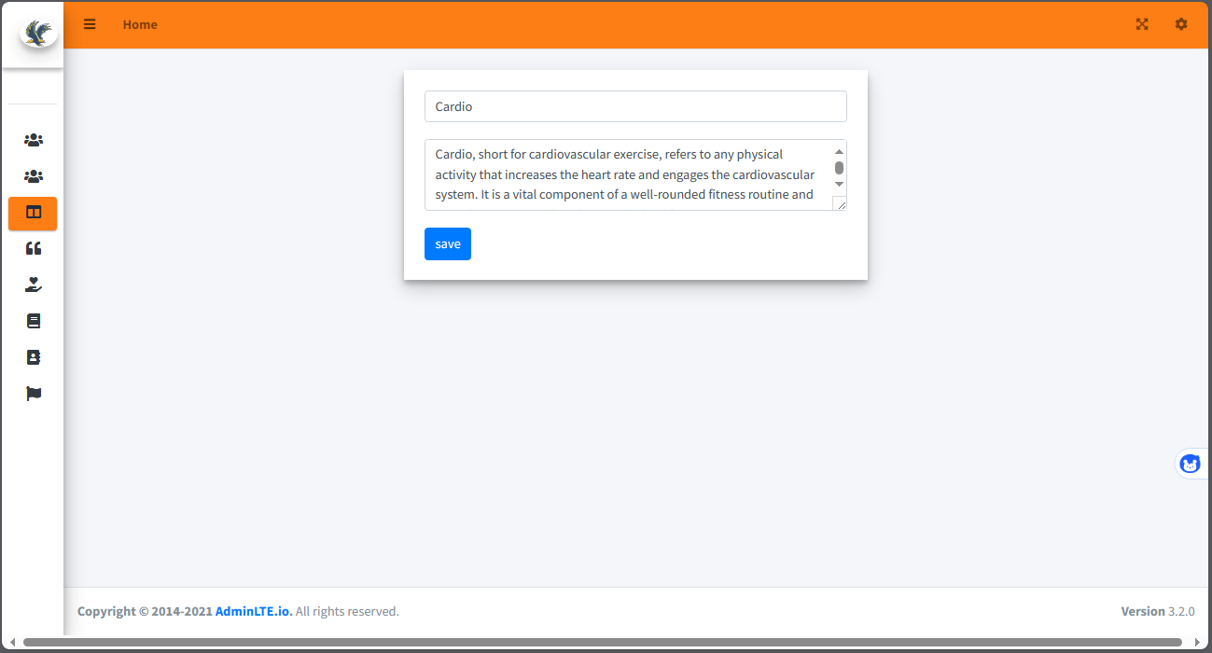

# Category delete

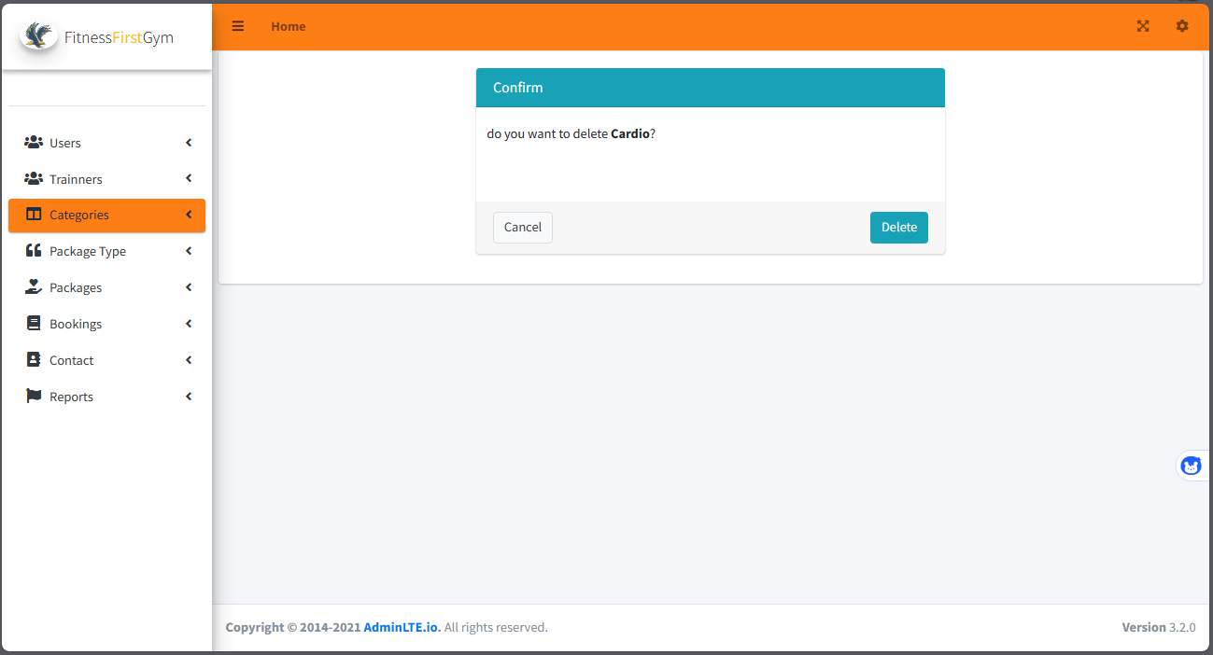

# Category create

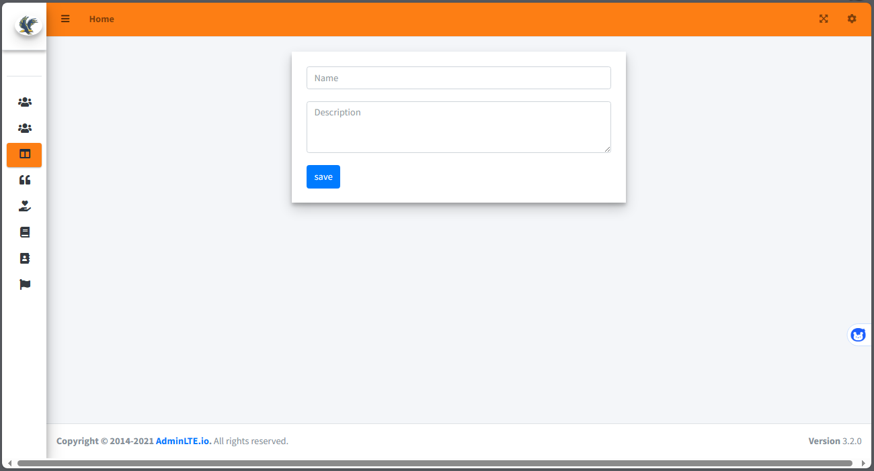

# Category search

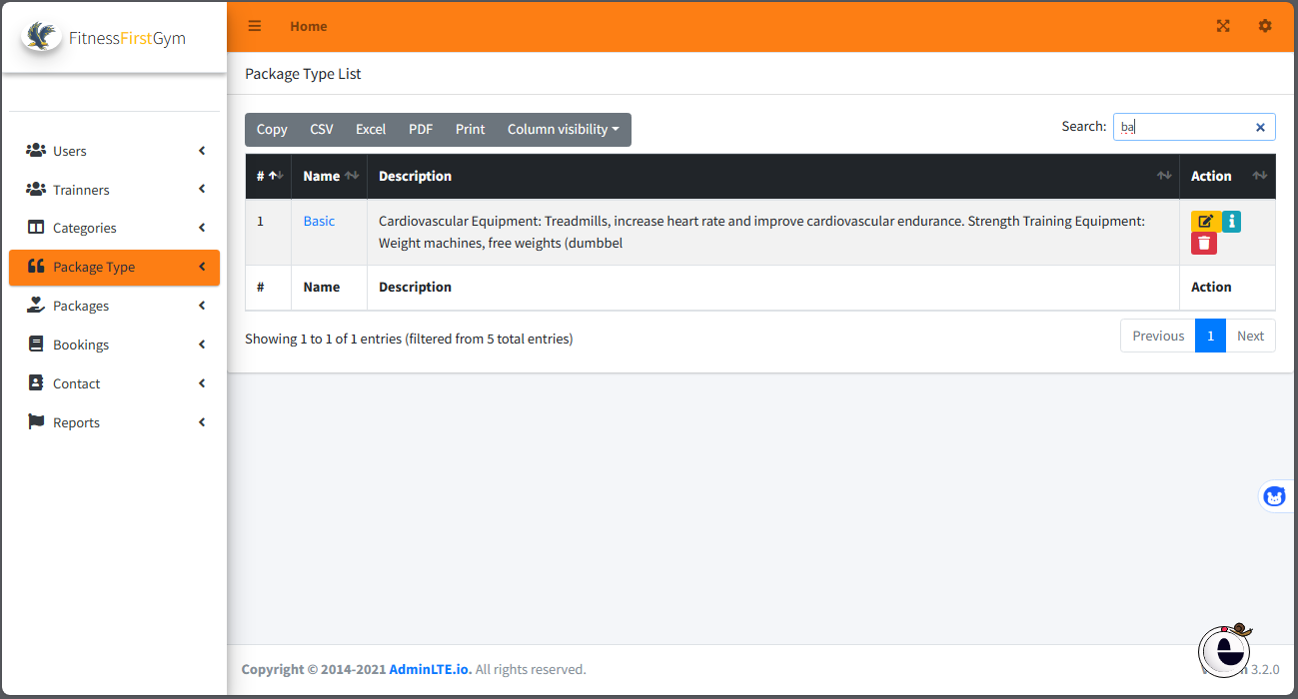

# Package Type List

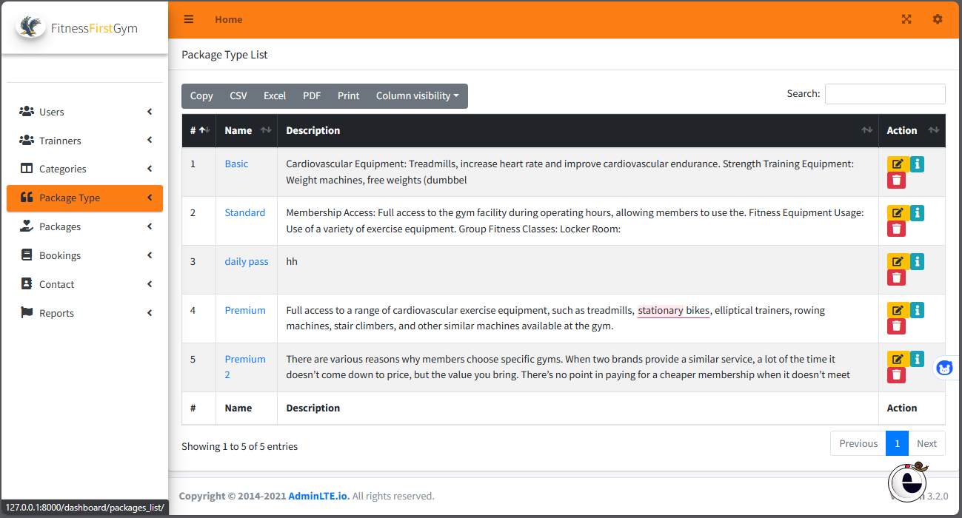

# Package Type Search



# Packages List

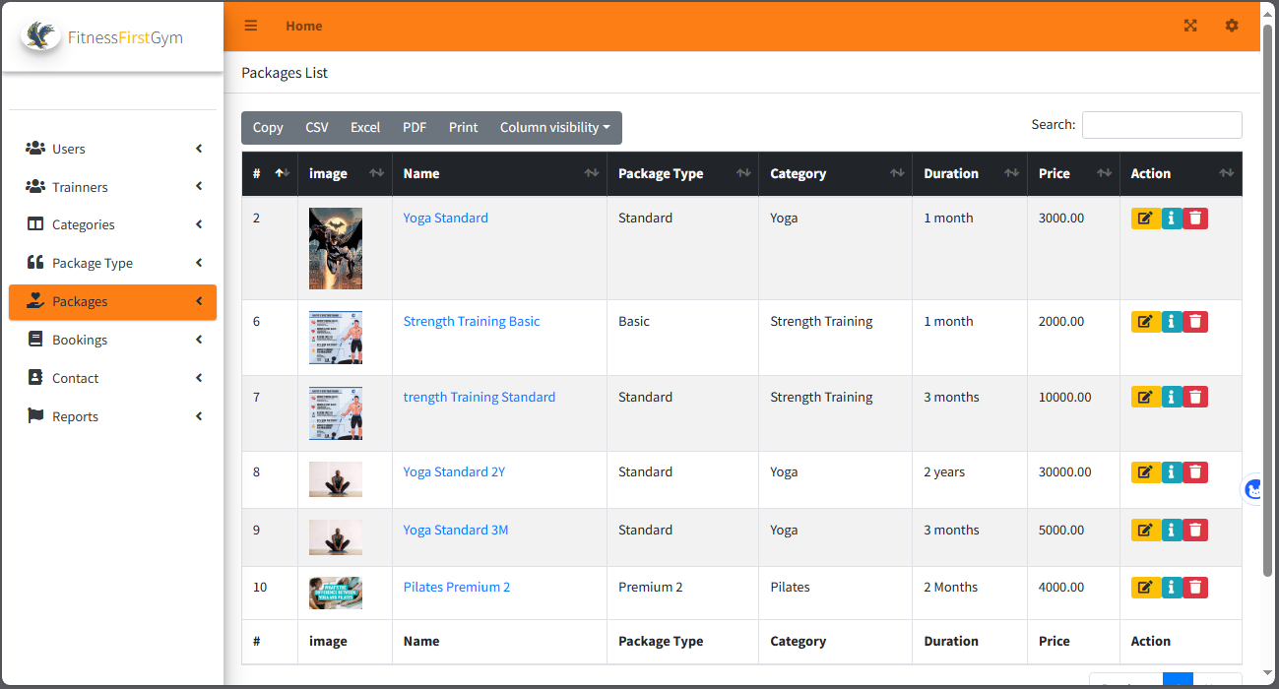

# Bookings List

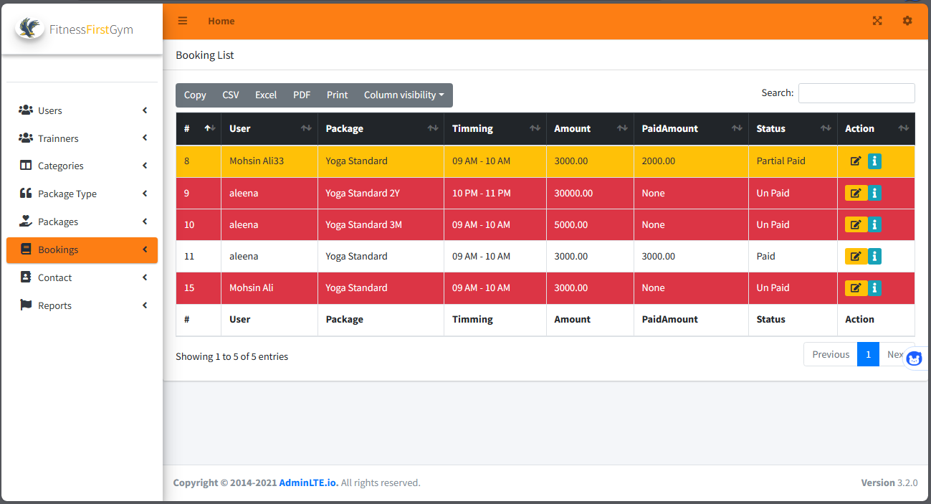

# Contact List

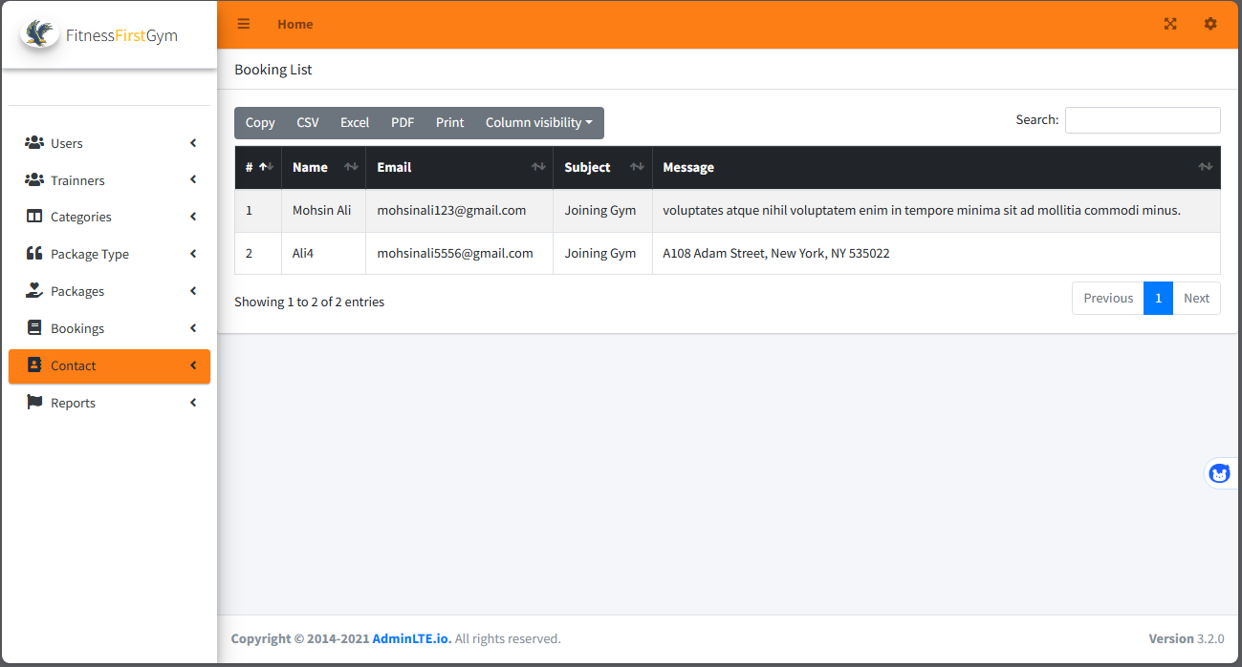

# Repost List

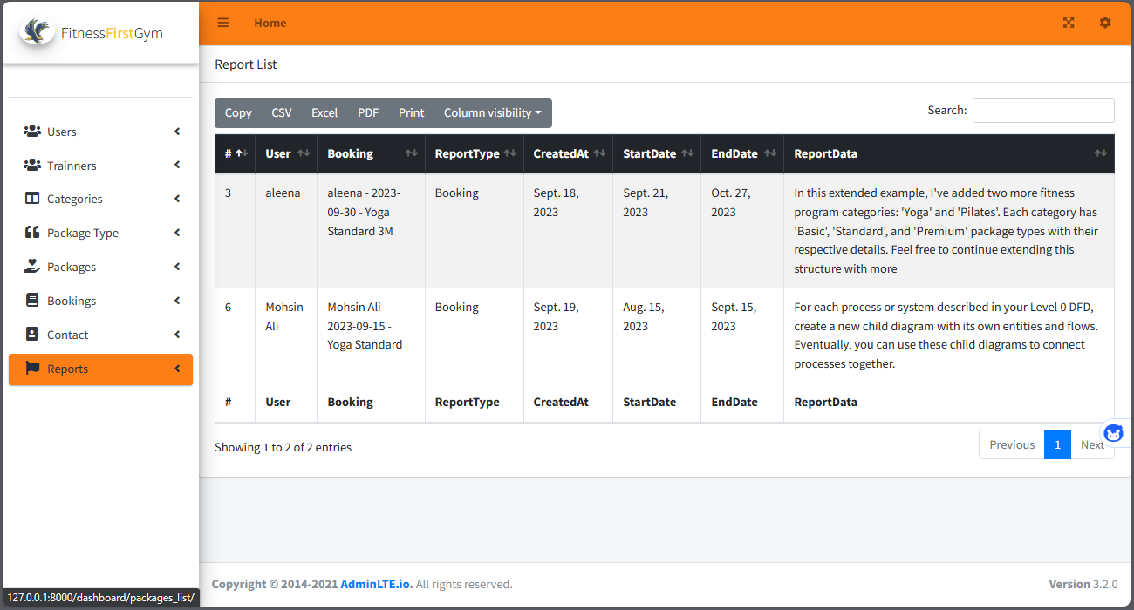

# Report create

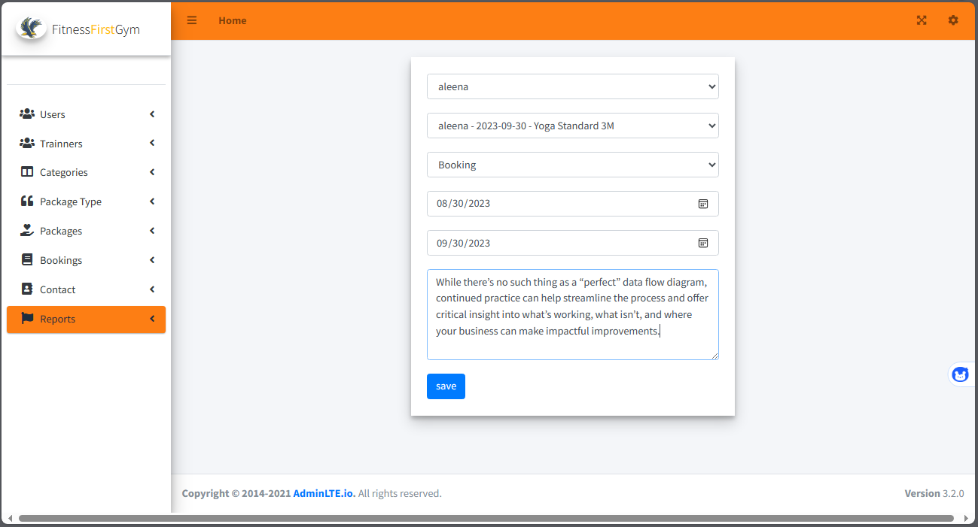

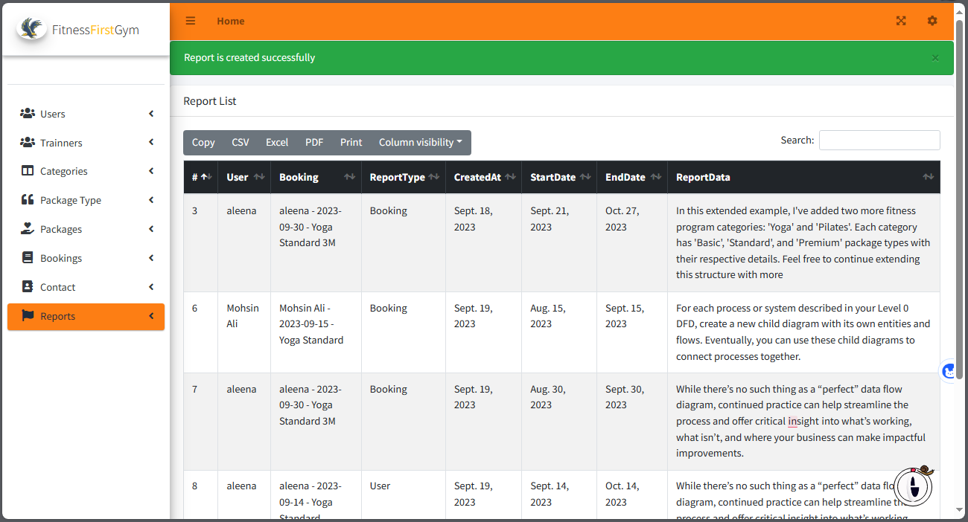

# Sign out

